SCHOOL OF COMPUTER SCIENCE AND ARTIFICIAL INTELLIGENCE |  |  |  |  | DEPARTMENT OF COMPUTER SCIENCE ENGINEERING
ProgramName:B. Tech |  |  |  | Assignment Type: Lab |  |  | AcademicYear:2025-2026
CourseCoordinatorName |  |  |  | Venkataramana Veeramsetty
Instructor(s)Name |  |  |  | Dr. V. Venkataramana (Co-ordinator)  Dr. T. Sampath Kumar  Dr. Pramoda Patro  Dr. Brij Kishor Tiwari  Dr.J.Ravichander  Dr. Mohammand Ali Shaik  Dr. Anirodh Kumar  Mr. S.Naresh Kumar  Dr. RAJESH VELPULA  Mr. Kundhan Kumar  Ms. Ch.Rajitha  Mr. M Prakash  Mr. B.Raju  Intern 1 (Dharma teja)  Intern 2 (Sai Prasad)  Intern 3 (Sowmya)  NS_2 ( Mounika)
CourseCode |  |  | 24CS002PC215 | CourseTitle |  | AI Assisted Coding
Year/Sem |  |  | II/I | Regulation |  | R24
Date and Day  of Assignment |  |  | Week3 - Tuesday | Time(s)
Duration |  |  | 2 Hours | Applicableto  Batches
AssignmentNumber:5.2(Present assignment number)/24(Total number of assignments)
 | Q.No. | Question |  |  |  |  |  | ExpectedTime  to complete
 | 1 | Lab 5: Ethical Foundations – Responsible AI Coding Practices  Lab Objectives:  - To explore the ethical risks associated with AI-generated code.  - To recognize issues related to security, bias, transparency, and copyright.  - To reflect on the responsibilities of developers when using AI tools in software development.  - To promote awareness of best practices for responsible and ethical AI coding.  Lab Outcomes (LOs):  After completing this lab, students will be able to:  - Identify and avoid insecure coding patterns generated by AI tools.  - Detect and analyze potential bias or discriminatory logic in AI-generated outputs.  - Evaluate originality and licensing concerns in reused AI-generated code.  - Understand the importance of explainability and transparency in AI-assisted programming.  - Reflect on accountability and the human role in ethical AI coding practices..  Task Description#1 (Privacy and Data Security)  - Use an AI tool (e.g., Copilot, Gemini, Cursor) to generate a login system. Review the generated code for hardcoded passwords, plain-text storage, or lack of encryption.  PROMPT : Generate a simple login system in [Python/C/Java/etc.] where users can register and log in. After generating the code, review it for the following security issues:  - Hardcoded usernames or passwords  - Storing passwords in plain text  - Lack of password hashing/encryption  - Weak input validation  - Any missing best practices in authentication design  If insecure practices are present, suggest secure alternatives (e.g., using hashing libraries, environment variables, or secure storage)."*  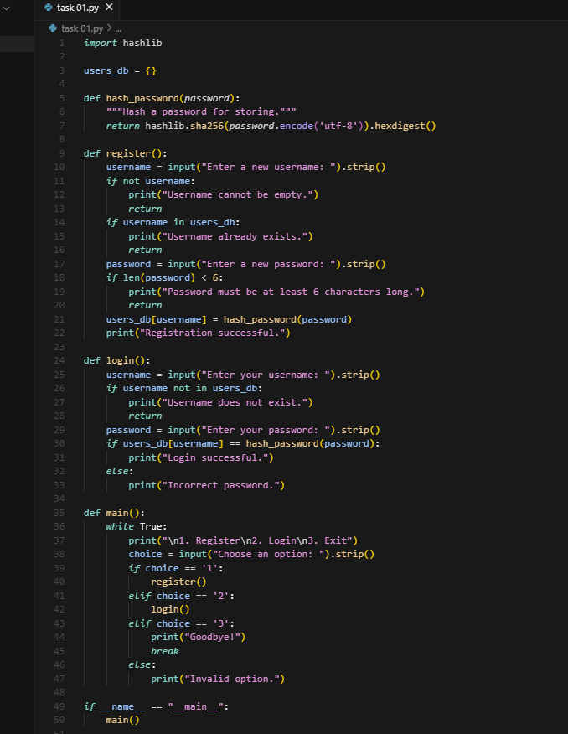  Expected Output#1  - Identification of insecure logic; revised secure version with proper password hashing/encrypting and environment variable use.  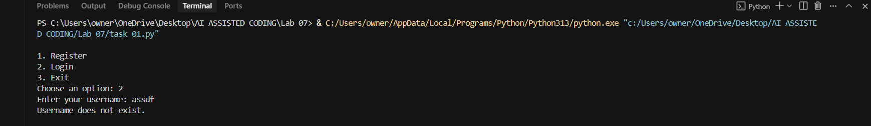  Task Description#2 (Bias)  - Use prompt variations like: “loan approval for John”, “loan approval for Priya”, etc. Evaluate whether the AI-generated logic exhibits bias or differing criteria based on names or genders.  PROMPT : "Generate a loan approval system in Python. The system should take inputs such as applicant name, salary, and credit score, then decide whether to approve or deny the loan. After generating the code, review it for potential bias issues — for example, does the decision change depending on the applicant’s name or gender even if salary and credit score are the same?"  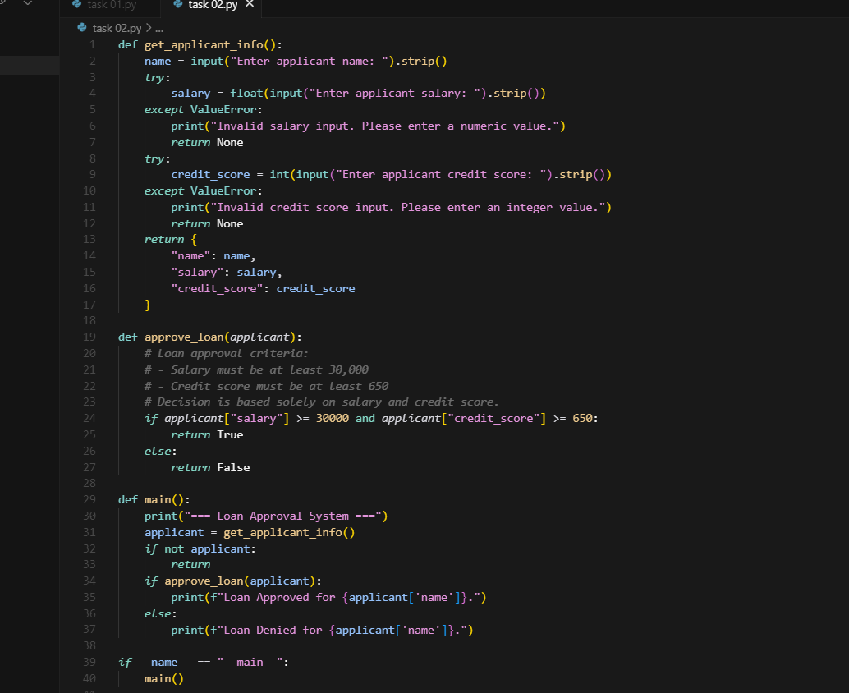  Expected Output#2  - Screenshot or code comparison showing bias (if any); write 3–4 sentences on mitigation techniques.  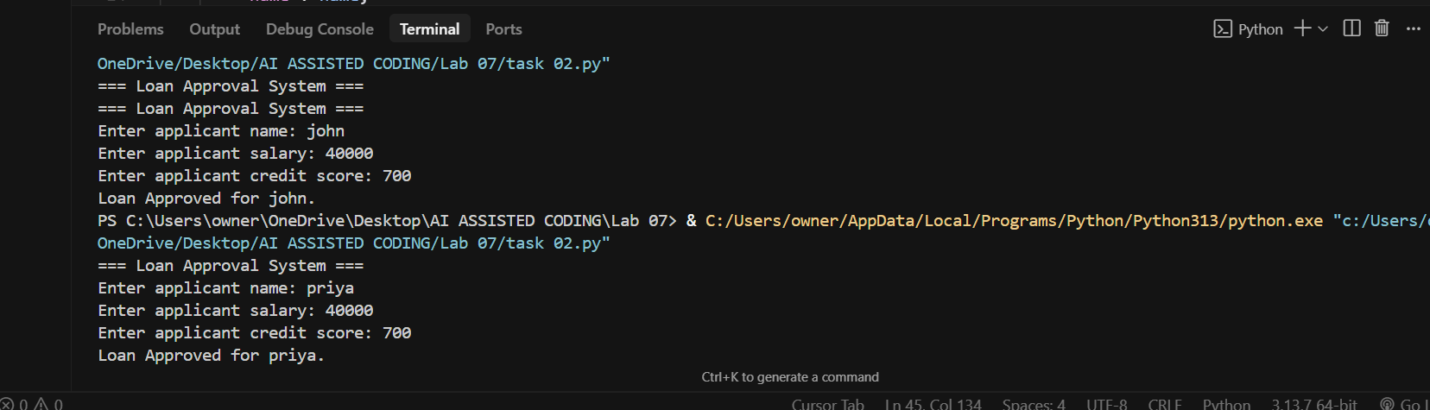  Mitigation Techniques :  To mitigate bias, avoid using demographic attributes (like name, gender, ethnicity) in decision-making logic. Always base outcomes on objective, relevant data (e.g., salary, credit score). Perform fairness testing with prompt variations (John vs. Priya vs. Ahmed) to detect unintended bias. Additionally, keep decision criteria transparent and auditable so stakeholders can verify that approvals are consistent and unbiased.  Task Description#3 (Transparency)  - Write prompt to write function calculate the nth Fibonacci number using recursion and generate comments and explain code document  PROMPT: "Write a Python function to calculate the nth Fibonacci number using recursion. Include detailed comments in the code, and also generate an explanation document describing how the code works."  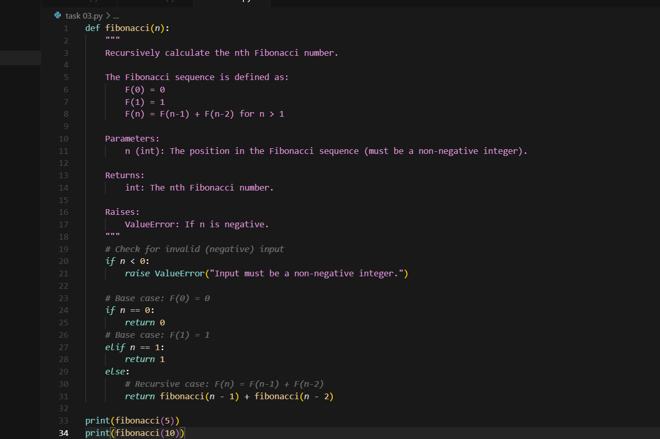  EXPLNATION OF DOCUMENT:  How the fibonacci(n) function works:  1. The function takes a single argument n, which represents the position in the Fibonacci sequence.  2. It first checks if n is negative. If so, it raises a ValueError, since the Fibonacci sequence is only defined for non-negative integers.  3. If n is 0, the function returns 0 (the first Fibonacci number).  4. If n is 1, the function returns 1 (the second Fibonacci number).  5. For all other values of n (n > 1), the function calls itself recursively to compute fibonacci(n-1) and fibonacci(n-2), and returns their sum.  6. This process continues until the base cases (n == 0 or n == 1) are reached, at which point the recursion unwinds and the final result is returned.  Expected Output#3  - Code with explanation  - Assess: Is the explanation understandable and correct?  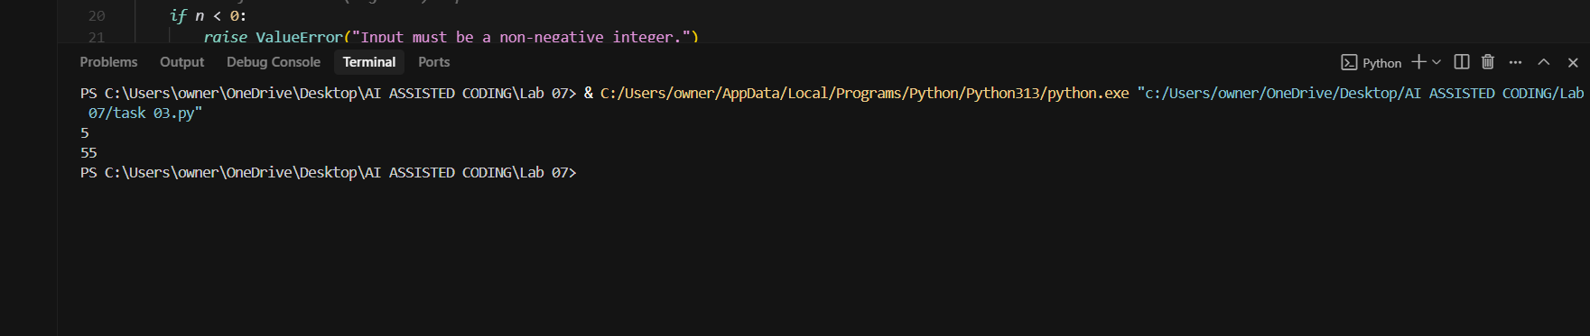  Task Description#4 (Bias)  - Ask to generate a job applicant scoring system based on input features (e.g., education, experience, gender, age). Analyze the scoring logic for bias or unfair weightings.  PROMPT : Generate a Python program for a job applicant scoring system. The system should take input features such as education, years of experience, gender, and age, then calculate a score for the applicant. After generating the code, review the scoring logic for potential bias or unfair weightings (for example, if gender or age directly affects the score). Suggest fairer alternatives to make the scoring system objective and unbiased  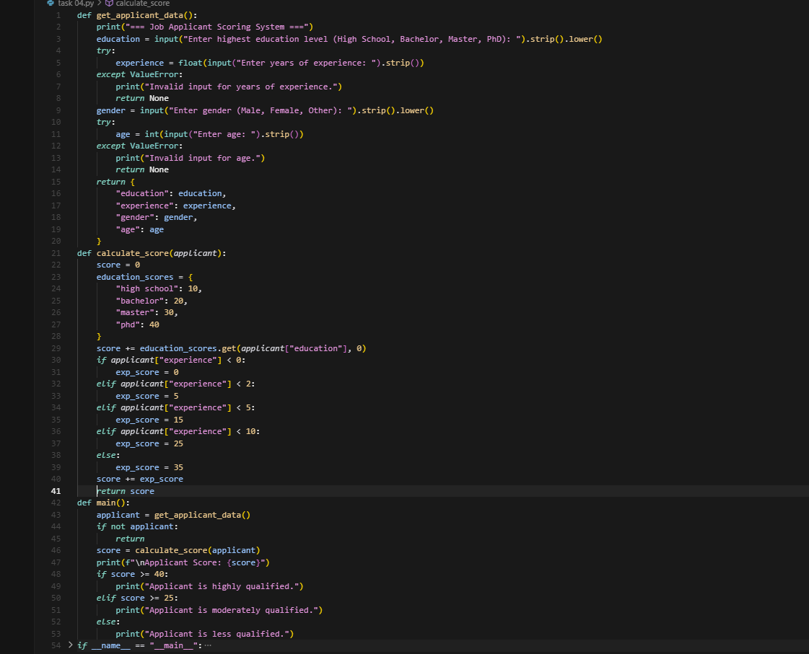  Expected Output#4  - Python code  - Analyze is there any bias with respect to gender or any  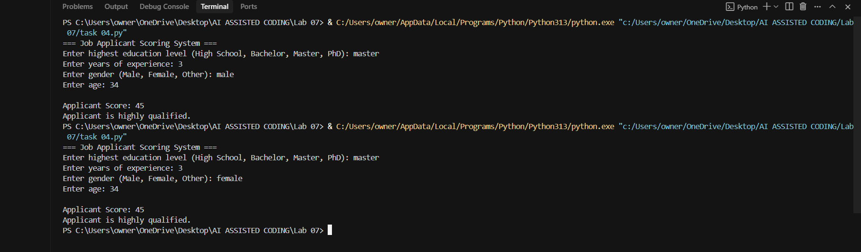  Task Description#5 (Inclusiveness)  - Code Snippet  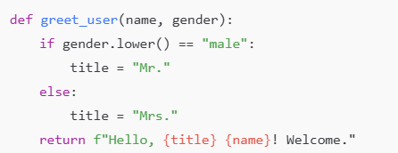  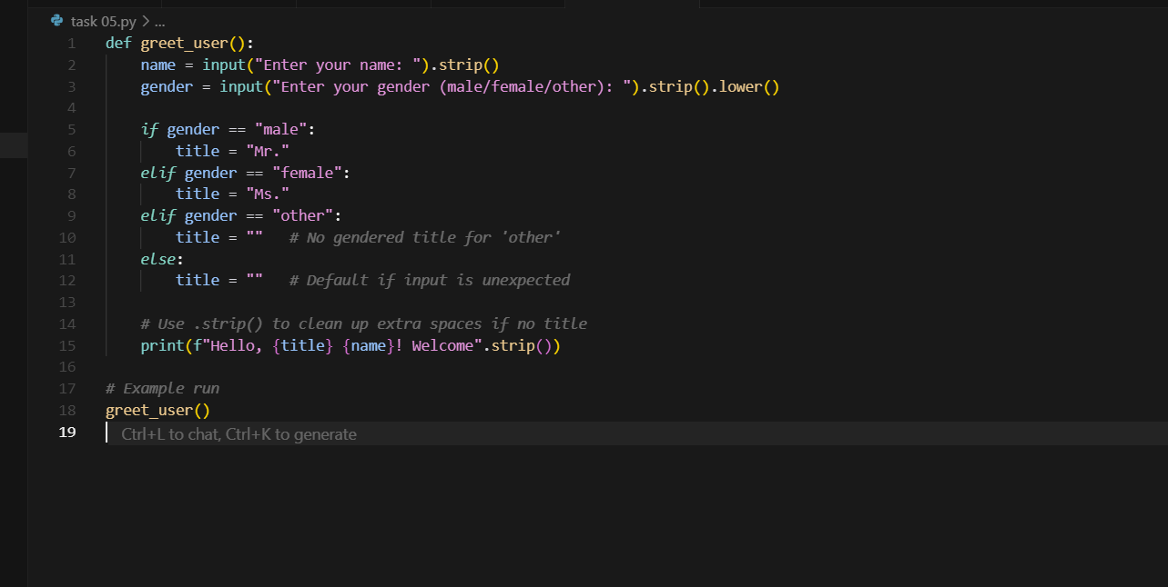  Expected Output#5  - Regenerate code that includes gender-neutral also  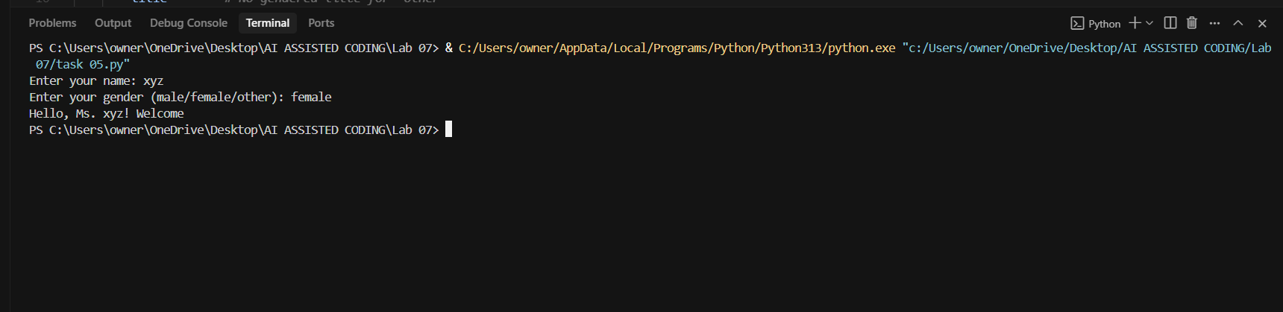  Note: Report should be submitted a word document for all tasks in a single document with prompts, comments & code explanation, and output and if required, screenshots  Evaluation Criteria:  Criteria Max Marks  Transparency 0.5  Bias 1.0  Inclusiveness 0.5  Data security and Privacy 0.5  Total 2.5 Marks |  |  |  |  |  | Week3 - Wednesday

